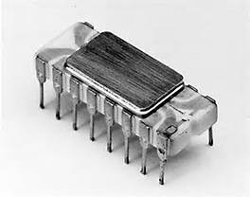

Embedded Control Systems (Microprocessor/Microcontroller) for Industry Process Control and Automation Mechatronics

Purpose : To give the participant a thorough knowledge, how Microprocessors/Microcontrollers act in the
process controls in the industry on an electronic hardware view point as well as the practical
knowledge, related components to design their own hardware for simple controlling or
monitoring gadgets.
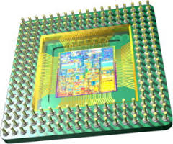
Aimed Group : Industry Engineers/Technicians working in production using Modern Controllers, Technical
Institute personnel.
Course Duration : Saturday & Sunday (9.30 AM – 6.00 PM) –Total 100hour course
No. of Participants : Maximum is 20
Course Flow : Morning Session Lectures (3 hours), Afternoon Session Lectures (5 hours)
Lunch Session 12.30 PM-1.00PM
Venue : Lecture Venue-Old Auditorium of ACCIMT, Practical Venue-Comm Lab of ACCIMT
Commencement :
Course Fee : Rs.35,000.00 inclusive of Lunch-Tea, Printed materials, CD and a PIC Microcontroller
Programmer / Demonstration board.
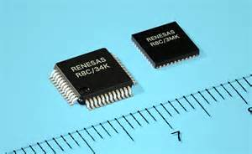
Details of course : The course consists of Theory sessions(1/3),Practical sessions(2/3),of the total duration. Hand’s on experience of for individuals on the Microcontroller applications with the components
provided. The practicals are conducted in the well equipped embedded controller labs having
latest development tools, equipments/instruments and by experienced Research Engineers.
Arthur C. Clarke Institute for Modern Technologies, Katubedda, Moratuwa.
: 011-2651880 : 011-2650462 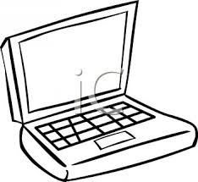: kavindra@accmt.ac.lk
1.Introduction to Microprocessors/Microcontrollers used in industry (3 hour lecture, 5 hour practical)
Course Contents or syllabus
- Pin connections of a microprocessor, microcontroller
- Difference between a microprocessor & a microcontroller
- Interfacing to the outside world
- Microprocessors/microcontrollers related components from common manufactures
- Specifications of a microcontroller/ microprocessor
- Today’s trend from microprocessor to microcontroller
2. Microcontroller related components (6 hour lecture, 10 hour practical)
- Common interfaces to the industry requirements
- Development tools like Editors, Simulators, Emulators, Debuggers and Programmers, C-Compilers
- Printed circuit boards & evaluation circuits
3.Details of microcontroller related peripherals (6 hour lecture, 10 hour practical)
- Ports for input & output control
- Universal Synchronous Asynchronous Receiver Transmitter
- Analog to Digital converters
- Tumors/ Counters/ Plus Width Modulators
- Serial Peripheral Controlling (SPI, I²C)
- EPROM, E²ROM, FLASH memory
. Basic Microcontroller applications using Microchip PIC Microcontrollers (12 hour lecture, 20 hour practical)
- Microcontroller data sheets of PIC 16F84A & PIC16F876/ PIC16F877
- Writing Assembly Programs
- LED & Switch button applications using port pins
- Communicating with a PC
- Analogue to Digital conversion
- Getting a time delay
- Use of SPI interface a Display IC (MAX7219)
5. Industry applications using Microchip PIC Microcontrollers (12 hour lecture, 20 hour practical)
- How to write & use Assembly & C programs
- Development tools used for these applications
- Interfacing a seven segment display IC (MAX7219)
- Interfacing a temperature sensors to the system & the current temperature display
- Interfacing key buttons to the system & entering input data
- Controlling a heater according to a set temperature for process controlling
- Interfacing a Liquid Crystal Display(LCD)
- Controlling relays, motors
- Designing techniques for Microcontroller based products

