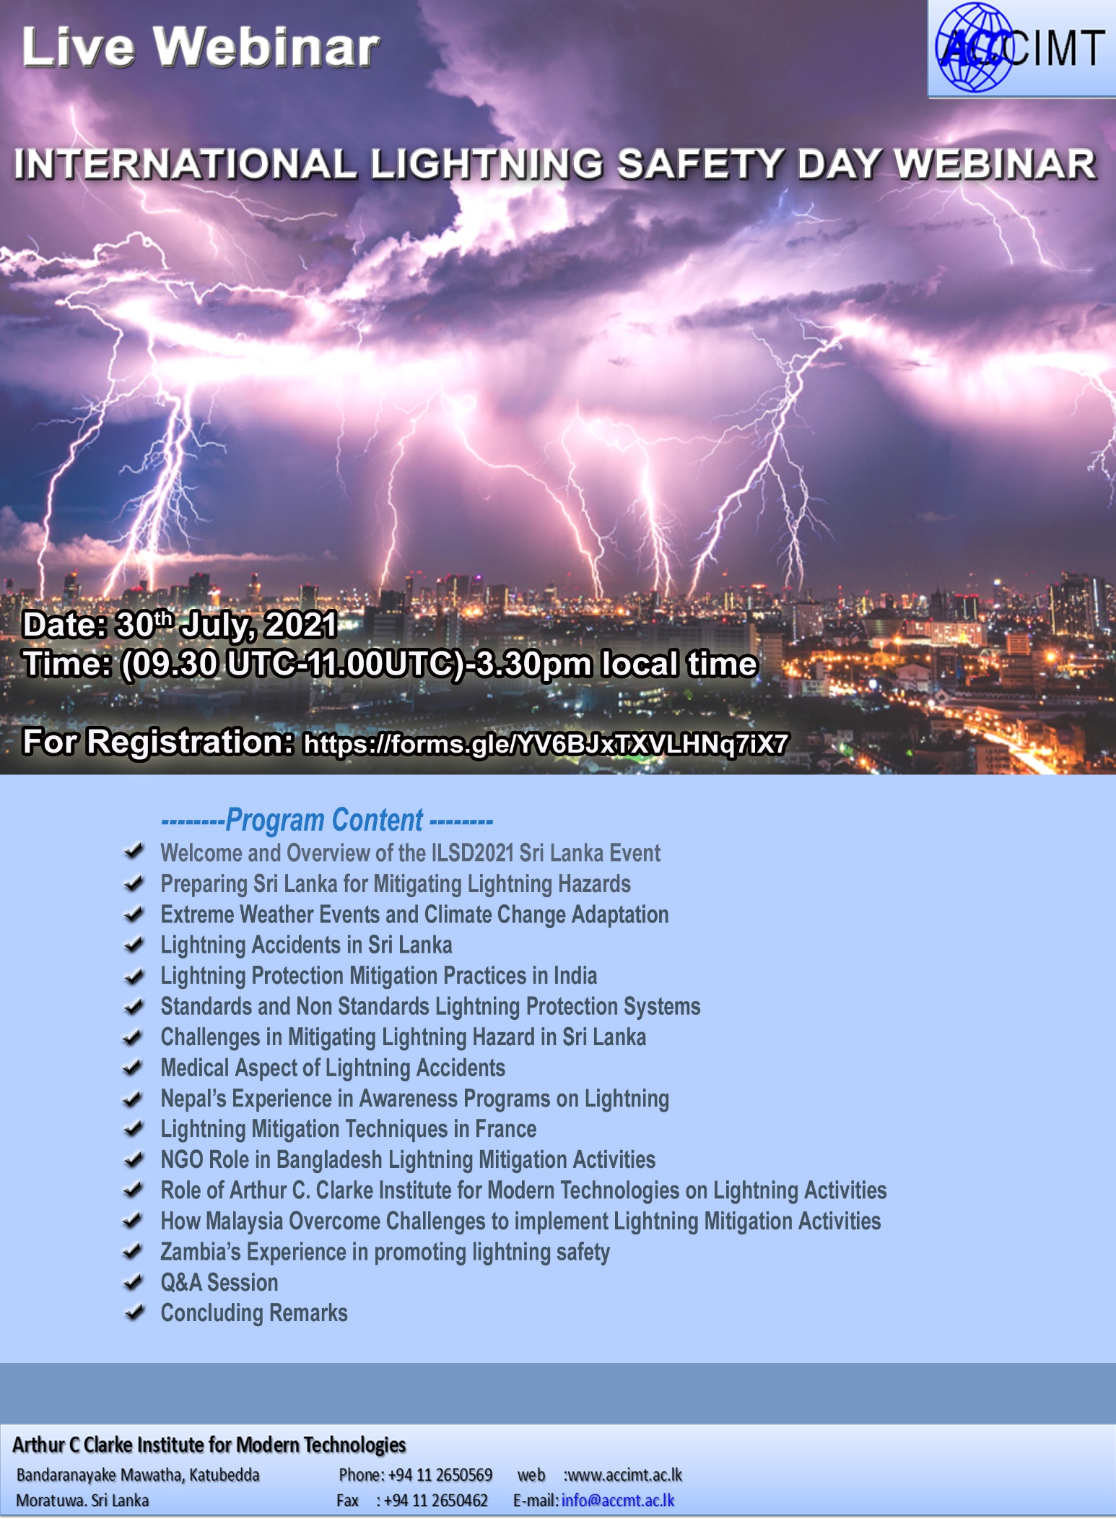

Arthur C Clarke Institute for Modern Technologies
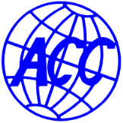
International Lightning Safety Day
ILSD 30th July 2021

International Lightning Safety Day, 28 June 2021, marks the tenth anniversary of the day a single lightning flash killed eighteen pupils and a teacher with thirty-eight pupils hospitalized for days on June 28, 2011 at the Runyanya Primary School in the Kiryandongo district, Uganda.

Every year lightning kills thousands of people worldwide. International Lightning Safety Day was initiated to not only call attention to the dangers of lightning, but also to draw attention to the problem related to lightning safety and protection in developing countries.

Lightning, as a random, scattered, and unpredictable event remains, one of the least attended natural hazards around the globe even though it claims thousands of lives of both humans and livestock and damage other important physical property every year.

Sri Lanka is experiencing several types of natural hazards, such as floods, strong winds, drought, heavy rain, and lightning, etc. As has been reported in research studies, as a tropical country, hazards due to lightning have been identified as one of the dominant natural hazards in Sri Lanka

People living in developing countries in South Asia are vulnerable to lightning damage, and—in the Sri Lankan context—it is one of the severe natural hazards which cause impairments to property and people. In general, antennas, wired network systems, etc. create an easy path for lightning strikes, and some activities—such as swimming, fishing, and walking in the open area during fatal lightning strikes—will increase the tendency of being victims of lightning hazards.

The aims of this ILSD2021 online conference are to enhance the awareness of the lightning safety of the community, and to take appropriate actions to mitigate lightning hazards effectively. A comprehensive study about regional lightning activities is an essential requirement to mitigate the lightning hazards of a country by identifying the highly lightning-active seasons and regions of that country. Detailed studies have been conducted concerning the awareness and lightning safety of the community, and it is important to conduct awareness programs, and to make people aware of lightning hazards and the safety methods available for the public community.

As an outcome of such a Webinar we look forward to hear about the new innovative plans against ‘Lightning Safety’ from different parties in the society.

Registration is FREE at https://forms.gle/YV6BJxTXVLHNq7iX7
THANK YOU FOR JOINING US………

Arthur C Clarke Institute for Modern Technologies
Bandaranayake Mawatha, Katubedda Phone: +94 11 2650569 web : www.accimt.ac.lk
Moratuwa, Sri Lanka Fax : +94 11 2650462 E-mail : info@accmt.ac.lk

INTERNATIONAL LIGHTNING SAFETY DAY WEBINAR
PROGRAM AND SPEAKERS
NOTE: all times UTC 30th JULY 2021(09:30 UTC- 11:00 UTC)-3.30pm local time
Agenda | Speaker | Time Duration (Min.)
Welcome and Overview of the ILSD2021 Sri Lanka Event | Eng. Sanath Panawennage-  DG/CEO-ACCIMT | 7
Preparing Sri Lanka for mitigating Lightning Hazards, identification of lightning hotsopts | Dr. Shiromi Jayawardane | 5
Extreme Weather Events and Climate Change Adaptation | Mr. Sarath Premalal- Former DG Department of Meteorology | 5
Lightning Accidents in Sri Lanka | Mr. K.R. Abhyasingha- Former Director ,Department of Meteorology | 5
Lightning Protection Mitigation Practices in India | Eng. Gopa Kumar – Cape Electricals, India | 5
Standards and Non Standards Lightning Protection Systems | Prof. Chandima Gomes, University of Witwatersrand, Johannesburg, South Africa. | 5
Challenges in Mitigating Lightning Hazard in Sri Lanka | Eng. Nuwan Kumarasinghe, Former Chief Electrical Engineer, Department of Meteorology | 5
Medical Aspect of Lightning Accidents | Prof. Mary Ann Cooper-USA | 5
Nepal’s Experience in Awareness Programs on Lightning | Dr. Shriram Sharma-Chairman , South Asian Lightning Network-SALNET | 5
Lightning Mitigation Techniques in France | Dr. Stéphane Schmitt, Meteorage, France | 5
NGO Role in Bangladesh Lightning Mitigation Activities | Dr. Munir Ahmed | 5
Role of Arthur C. Clarke Institute for Modern Technologies on Lightning Activities | Eng. G G G R Gihara  Research Engineer- ACCIMT | 5
How Malaysia Overcome Challenges to implement Lightning Mitigation Activities | Prof. Zainal Kadir, Professor, Advanced Lightning, Power & Energy Research Center (ALPER), UPM, Malaysia. | 5
Zambia’s Experience in promoting lightning safety | Eng. Foster Lubasi – Director , ZaCLIR | 5
 | TOTAL TIME | 72
Q&A Session | Panelists: Eng. Sanath Panawennage , Prof. Chandima Gomes, Prof. Mary Ann Cooper, Dr. Shri Ram Sharma, Prof. Zainal Kadir, Dr. Shiromi Jayawardane, , Mr. K.R. Abhyasingha, Eng. Gopa Kumar, Eng. Janaki Athuraliya,  Moderator: Eng. Nuwan Kumarasinghe | 15
Concluding Remarks | Eng. J Athuraliya -ACCIMT | 3
Note: Topics/Names /duration are subject to be changed.

